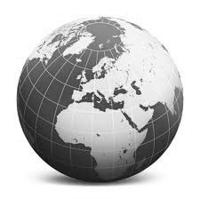
Seventh Grade Social Studies

Two-part course taught in sixth grade and seventh grade

Seventh Grade Sequence: European Geography and Ancient History; European Geography, Modern Europe, and Contemporary Issues; Latin America; Canada and the United States

- Current events are integrated in the units

- Focus on discipline literacy -- Reading and writing skills are embedded in the social studies curriculum Reading Like a Historian

- Specific objectives and inquires have been developed for the Gifted and Talented classes

- Books: Nystrom’s Desk Atlas and Glencoe’s Discovering World Geography

- Students must maintain a separate Social Studies binder

- There is routine, order, and structure to the class; monitor your child’s progress through the Agenda Book, quarterly grade sheets and goal sheets, and binder

- Homework: Approximately 1 to 1 1/2 hours of homework will be assigned per week (10-15 minutes per night); it is the student's responsibility to copy the homework in their Agenda Book, to obtain and hand in all work, and to make-up any missed assignments.

- Quizzes and tests are announced and information is posted (white board in Room 11 and electronically through HCPSS’s Canvas learning management system) approximately a week before they are given and study guides are provided

- Grades on HCPSS’s Canvas learning management system will be up-dated on a timely basis; for the most up-to-date information check your child’s grade sheet

- Best way to reach Ms. Apple is to write a note in your child’s Agenda Book or call school (410-313-5520) and leave a message

