Name: ___________________________ Period: _____ Date: __________________

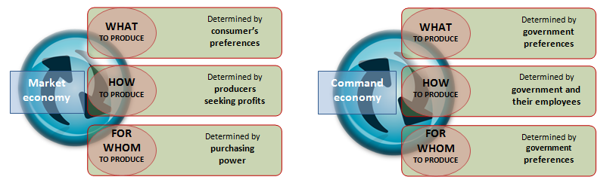
Market v. Command Economy

