Name: _______________________________________ Period: _________ Date: ________________________

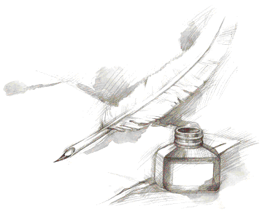
Argumentative Response
One Paragraph

Working Title of the Response: _______________________________________________________________________
Topic sentence – a well-written sentence to grab the reader: _________________________________________________
__________________________________________________________________________________________________
First reason: ______________________________________________________________________________________
Evidence to support your reason with document citation (cite the title, NOT the document letter or number): ___________ __________________________________________________________________________________________________
Argument/Explanation – connecting the evidence to the reason: ______________________________________________
__________________________________________________________________________________________________
Second reason: ____________________________________________________________________________________
Evidence to support your reason with document citation (cite the title, NOT the document letter or number): ___________ __________________________________________________________________________________________________
Argument/Explanation – connecting the evidence to the reason: ______________________________________________
__________________________________________________________________________________________________
Third reason –refute the opposition: __________________________________________________________________
Evidence to support your reason with document citation (cite the title, NOT the document letter or number): ___________ __________________________________________________________________________________________________
Argument/Explanation – connecting the evidence to the reason: ______________________________________________
__________________________________________________________________________________________________
Conclusion – restatement of main idea along with possible insight or wrinkle: ___________________________________ __________________________________________________________________________________________________

