Name: _______________________________________ Period: _________ Date: ___________________

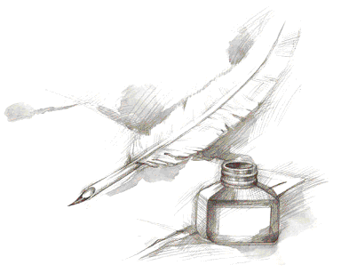
Historical Investigation
Three Paragraph Argumentative Response Outline Guide -- Prewriting

Prewriting

Outline your response. The purpose of this activity is to organize your thoughts before writing your answer. This step should be completed in 5-10 minutes. This is NOT a rough draft of your response.

Working Title of the Response: _______________________________________________________________________
Paragraph #1:
Topic sentence – a well-written sentence to grab the reader: _________________________________________________
__________________________________________________________________________________________________
First reason: ______________________________________________________________________________________
Evidence to support your reason with document citation (cite the title, NOT the document letter or number): ___________ __________________________________________________________________________________________________
Argument/Explanation – connecting the evidence to the reason: ______________________________________________
__________________________________________________________________________________________________
Paragraph #2:
Second reason: ____________________________________________________________________________________
Evidence to support your reason with document citation (cite the title, NOT the document letter or number): ___________ __________________________________________________________________________________________________
Argument/Explanation – connecting the evidence to the reason: ______________________________________________
__________________________________________________________________________________________________
Paragraph #3:
Third reason –refute the opposition: __________________________________________________________________
Evidence to support your reason with document citation (cite the title, NOT the document letter or number): ___________ __________________________________________________________________________________________________
Argument/Explanation – connecting the evidence to the reason: ______________________________________________
__________________________________________________________________________________________________
Conclusion – restatement of main idea along with possible insight or wrinkle: ___________________________________ __________________________________________________________________________________________________

