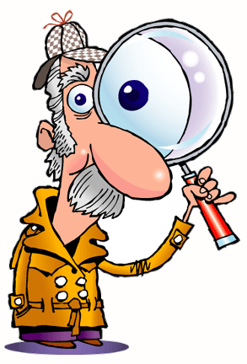
Audience

1. For whom might the author have created this source?
___________________________________________________

2. Was the source/document made for the public or was meant to be kept private? Circle one:

- public (published and distributed to a wide audience)
- private (intended only for a specific individual/group or for self – for instance, a journal)

Name: _____________________________________________________________ Period: _______ Date: __________________________________________
Sourcing
(Level 1)
Directions: Prior to reading and analyzing a document, consider the source and purpose of the document by completing this organizer.
Description

1. What do you see?
- A whole (complete) source/document or an excerpt (part)?
___________________________________________________

- Describe the printing (handwritten, typed, calligraphy, symbols, etc.)
___________________________________________________

- Describe the graphics (symbols, illustrations, key, photos, etc.)
___________________________________________________

- Other features?
___________________________________________________

2. What type of source? (letter, report, news article, etc.)
___________________________________________________

3. What is the title of the source?
___________________________________________________

4. When was the source created or produced? (date)
___________________________________________________

Author

1. Who created the source/document? __________________
___________________________________________________

2. What do you know/ infer about the author?
- Occupation, etc. ___________________________________
- Title, office, rank, or role in society ___________________
___________________________________________________

3. Specialized knowledge or experience of the author:
__________________________________________________
__________________________________________________

Purpose

1. Why was the source/document created? Circle one:
- To inform
- To persuade (an argument)
- To entertain
- Other: _____________________________________

2. Did someone benefit from this source? Circle one:
- Yes
- No
Explain: _____________________________________
_____________________________________________

3. Is there evidence of bias? Explain. _____________
_____________________________________________
_____________________________________________

4. Is the source primary or secondary? ___________

