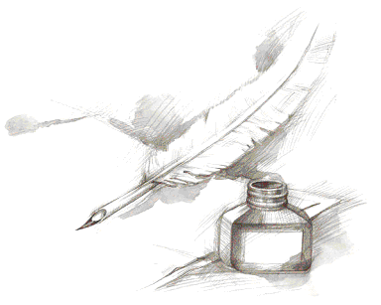
Writing Traits

- When giving evidence:
  - Cite the title, NOT the document letter or number, as an introduction to the evidence (the quote)
  - Use a quote (exact words) from the text
  - Use quotation marks around the quote
  - Make a smooth transition from the quote to the explanation
  - Your explanation must be logical and reasonable

- Linking words/phrases:
  - To introduce and organize details:
    - First
    - To begin with
    - Second
    - Next
    - Another
    - In addition
    - For example,

  - Refute:
    - Some may believe
    - Even though
    - Although
    - Even if

  - To begin the conclusion:
  - Therefore,
    - As a result,
    - Finally,
    - To summarize,
    - Thus,

- Word Choice:
- Addition:
also, again, as well as, besides, coupled with, furthermore, in addition, likewise, moreover, similarly
- Consequence:
accordingly, as a result, consequently, for this reason, for this purpose, hence, otherwise, so then, subsequently, therefore, thus, thereupon, wherefore
- Contrast and Comparison:
contrast, by the same token, conversely, instead, likewise, on one hand, on the other hand, on the contrary, rather, similarly, yet, but, however, still, nevertheless, in contrast
- Emphasis
above all, chiefly, with attention to, especially, particularly, singularly
- Exception:
aside from, barring, beside, except, excepting, excluding, exclusive of, other than, outside of, save
- Generalizing:
as a rule, as usual, for the most part, generally, generally speaking, ordinarily, usually
- Restatement:
in essence, in other words, namely, that is, that is to say, in short, in brief, to put it differently
- Summarizing:
after all, all in all, all things considered, briefly, by and large, in any case, in any event, in brief, in conclusion, on the whole, in short, in summary, in the final analysis, in the long run, on balance, to sum up, to summarize, finally

